ScikitLearn:

**What is Support Vector Machine?**

Support vector machines (SVMs) are a particularly powerful and flexible class of supervised algorithms for both classification and regression and outlier detection.

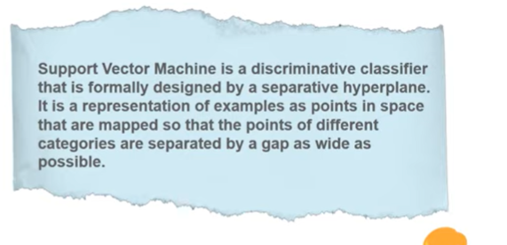 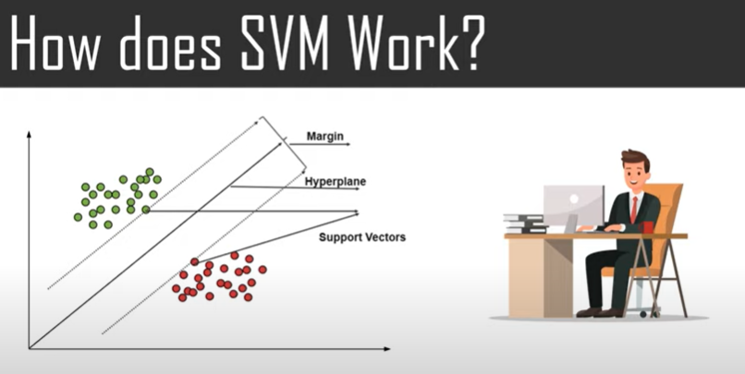

SVM'S MAIN OBJECTIVE IS TO SEGREGATE THE GIVEN DATA IN THE BEST POSSIBLE WAY. WHEN THE SEGREGATION IS DONE, THE DISTANCE BETWEEN THE NEAREST POINTS=MARGIN. THE APPROACH IS TO SELECT THE A HYPERPLANE WITH THE MAX POSSIBLE MARGIN BETWEEN THE SUPPORT VECTORS IN THE GIVEN DATA SET. **A hyperplane is a decision boundary that differentiates the two classes in SVM.**

TO SELECT THE MAX HYPERPLANE IN THE GIVEN SETS, SVM DOES THE FOLLOWING:

-GENERATES A HYPERPLANE WHICH SEGREGATES THE CLASSES IN THE BEST POSSIBLE WAY

-SELECTS THE RIGHT HYPERPLANE WITH THE MAX SEGREGATION FROM THE NEAREST DATA POINTS.

**What is Principal Component Analysis?**

Principal Component Analysis is basically a statistical procedure to convert a set of observations of possibly correlated variables into a set of values of linearly uncorrelated variables.

PCA, or Principal component analysis, is the main linear algorithm for dimension reduction often used in unsupervised learning.

- This algorithm identifies and discards features that are less useful to make a valid approximation on a dataset.

By reducing the number of features, PCA can help:

* Reduce the risk of overfitting a model to noisy features.
* Speed-up the training of a machine learning algorithm
* Make simpler data visualizations.

Principal component analysis, or **PCA**, is a statistical technique to convert high dimensional data to low dimensional data by selecting the most important features that capture maximum information about the dataset.

**What is Random Forest?**

 Random forest is a ***Supervised Machine Learning Algorithm*** that is ***used widely in Classification and Regression problems***. It builds decision trees on different samples and takes their majority vote for classification and average in case of regression.

It can handle the data set containing ***continuous variables*** as in the case of regression and ***categorical variables*** as in the case of classification.

* **DECSION TREE:** A Decision Tree is a Flow Chart, and can help you make decisions based on previous experience.  Decision-tree algorithm falls under the category of supervised learning algorithms. It works for both continuous as well as categorical output variables. Simple to understand and to interpret. Trees can be visualized. To make a decision tree, all data has to be numerical.

What is Neural Networks?

* + Neural networks, also known as artificial neural networks (ANNs) or simulated neural networks (SNNs), are a subset of [machine learning](https://www.ibm.com/cloud/learn/machine-learning) and are at the heart of [deep learning](https://www.ibm.com/cloud/learn/deep-learning) algorithms. Their name and structure are inspired by the human brain, mimicking the way that biological neurons signal to one another.
* A neural network is a series of algorithms that endeavors to recognize underlying relationships in a set of data through a process that mimics the way the human brain operates. In this sense, neural networks refer to systems of neurons, either organic or artificial in nature.
* Neural networks can adapt to changing input; so the network generates the best possible result without needing to redesign the output criteria.
* **Neural networks are a series of algorithms that mimic the operations of an animal brain to recognize relationships between vast amounts of data.**

Most of the neural networks that we design are feed forward and fully connected. This means that every neuron connects to every neuron in the next layer. The first layer receives inputs and the last layer gives outputs. The structure of the network, meaning the neuron counts and their connections, is decided ahead of time and cannot change, at least not during training. Also, every input must have the same number of values. This means that images, for example, may need to be resized to match the number of input neurons. The number of neurons in each layer is that layer's shape.

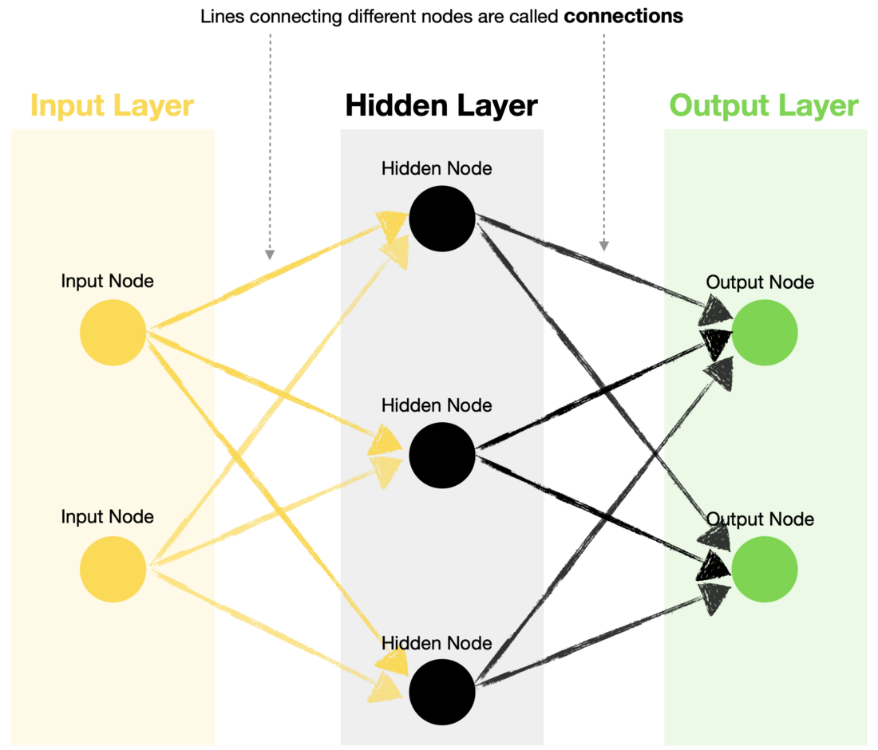

**What is Feedforward Neural Network?**

* + Are the main ideas behind basic Neural Networks
  + ***A Feed Forward Neural Network is an artificial Neural Network in which the nodes are connected circularly***
  + The basic type of neural network because the input is only processed in one direction.
  + The data always flows in one direction and never backwards/opposite.

**What is Backpropagation Neural Network?**

- Backpropagation in neural network is a short form for “backward propagation of errors.”

- is an algorithm for supervised learning of artificial neural networks using gradient descent.

- **Backpropagation is the central mechanism by which**[**artificial neural networks**](https://wiki.pathmind.com/neural-network)**learn. It is the messenger telling the neural network whether or not it made a mistake when it made a prediction.**

**-** To propagate is to transmit something (light, sound, motion or information) in a particular direction or through a particular medium

**-To backpropagate is to transmit something in response, to send information back upstream – in this case, with the purpose of correcting an error.**

**-** Backpropagation is synonymous with correction.

**Explain Convolution, its importance and its mathematics.**

The term convolution refers to **the mathematical combination of two functions to produce a third function.**

**-** Convolution is an orderly procedure where two sources of information are intertwined; it’s an operation that changes a function into something else.

**-** Convolutions have been used for a long time typically in image processing to blur and sharpen images, but also to perform other operations. (e.g. enhance edges and emboss)

- *A convolution is a filter that passes over an image, processing it, and extracting features that show a commonality in the image.*

**What is CNN?**

Convolutional Neural Network is **a Deep Learning algorithm specially designed for working with Images and videos**. It takes images as inputs, extracts and learns the features of the image, and classifies them based on the learned features.

Train test split: